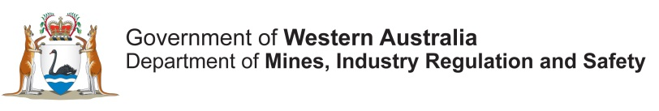

CO-FUNDED GOVERNMENT – INDUSTRY DRILLING PROGRAM
DEPARTMENT OF MINES, INDUSTRY REGULATION and SAFETY,
WESTERN AUSTRALIA

June 2022 – May 2023 program

Guidelines for Submission of Applications

CONTENTS

Contents
1. INTRODUCTION 2
2. DEFINITIONS 2
3. TIMELINES AND IMPORTANT DATES FOR 2022–2023 CO-FUNDING 3
4. HOW TO APPLY FOR GRANT FUNDING 5
5. APPLICATION ASSESSMENT 5
6. IMPORTANT FUNDING INFORMATION 5
6a. Prospector Grants 6
6b. Mobilization costs – zone dependent 7
6c. Core tray costs – diamond drilling 9
6d. Co-funded drilling and Plan for Our Parks. 11
7. DOCUMENT GUIDELINES AND ASSESSMENT CRITERIA 12
8. LEGAL PARAMETERS OF PROPOSALS 14
9. CONDITIONS OF ACCEPTANCE FOR SUCCESSFUL APPLICANTS 15
10. FINAL REPORT SUBMISSION AND FURTHER INFORMATION 16
APPENDIX 1 17
Environmental guidelines (petroleum and mineral exploration) 17
APPENDIX 2 17
Drill core guidelines (includes core submission form) 17
APPENDIX 3 17
Guidelines for mineral exploration reports 17
APPENDIX 4 17
Guidelines for petroleum and geothermal exploration reports 17

Please refer to the website of the Department of Mines, Industry Regulation and Safety for the latest information on the Co-funded Government – Industry Drilling Program.

Homepage: http://www.dmirs.wa.gov.au/
Released: July 2020 Version 2 (new – core tray, mobilization, prospector $1000)
Amended: December 2021

1. INTRODUCTION

The Co-funded Government - Industry Drilling Program is being funded by the Western Australian State Government, to provide a stimulus to geoscience exploration and contribute to the economic development of regional areas of Western Australia. Over $175 million has been provided to the Exploration Incentive Scheme between 2009 to June 2021. The State Government has now extended funding for the Exploration Incentive Scheme from July 2021 at $12.5M per year. The program is administered by the Department of Mines, Industry Regulation and Safety (DMIRS).

Geoscience exploration includes mineral, oil and gas, and geothermal exploration with drilling to be undertaken in underexplored areas.

The Department is now seeking proposals from applicants to undertake exploration drilling projects jointly funded by the successful applicants and the Department.

In 2022–23 the co-funded drilling program will consider applications from anywhere in the State and will preferentially fund high quality, technically and economically sound proposals that promote new exploration concepts and new exploration technologies.
Within this co-funded drilling program a separate pool of funding will be available for bona fide prospectors.
Two changes will be made to the co-funded drilling program in Round 25 on a trial basis.
1. The single deep-hole category will accept applications for one OR two deep-hole programs.
2. The Government contribution to each successful general application project will increase. The new contribution will be capped at $220,000 for a project consisting of one or two deep hole(s), $180,000 for a project with multiple holes and $40,000 for a prospector’s grant.
As the Scheme is voluntary, successful applicants agree to the release to Open File of all new information from drilling, after a maximum confidentiality period of six months from payment of the first invoice. This includes ½ diamond core (minimum) submitted to a DMIRS Core Library (if diamond drilling is undertaken as part of the application).

2. DEFINITIONS

“Director General” means the Director General of the Department of Mines, Industry Regulation and Safety.

“Minister” means the Minister for Mines and Petroleum.

“Applicant” means the company, institution or individual submitting a proposal.

“Funding Agreement” means the agreement of conditions of funding grant between the parties. These Guidelines form part of the Funding Agreement.

“Proposal” means the documentation prepared and submitted to the Director General in an application for Government - Industry Drilling Co-funding.

“Project” means the work undertaken by the successful Applicant in accordance with the Proposal.
“Prospector” means an individual who holds and explores on a single or small group of granted tenement/s with no public company ownership.

“Prospector Grant” means a grant made to a prospector and is capped at $30,000 per grant. Only one application may be submitted per tenement or combined reporting group.

“Closing Date” means 4 pm WST on the 4 March 2022. This is the last day to submit a proposal. The online submission of the application must be completed at this time.

“Completion Date” means the date of submission of final report including core. This must not be later than 5 pm, 31 August 2023 (finalisation of the project), unless otherwise agreed with DMIRS.

“Drilling Co-funding” means monies distributed to successful applicants on completion of projects.
“Mining Tenement” means the area (or part thereof) outlined in the Proponent’s licence or lease granted under the Mining Act 1978 (WA).

“Petroleum Title” means the area (or part thereof) outlined in the Proponent’s licence, lease or permit granted under the Petroleum and Geothermal Energy Resources Act 1967 (WA).

“Geothermal Title” means the area (or part thereof) outlined in the Proponent’s licence, lease or permit granted under the Petroleum and Geothermal Energy Resources Act 1967 (WA).

3. TIMELINES AND IMPORTANT DATES FOR 2022–2023 CO-FUNDING

Important dates for the 2022–2023 Co-funded Drilling Program:

7 February 2022 | Online applications open
4 March 2022 | Online applications close (4 pm WST deadline)
Mid-Late April 2022 | Planned announcement of successful Proposals
By 31 May 2022 | Agreements signed by Applicants and DMIRS
1 June 2022 – 31 May 2023 | Term of Funding Agreement for 2022 Co-funded Drilling
31 May 2023 | Last date for acceptance of Interim Reports and invoices and drillers receipts for 2022–2023 drilling projects (5 pm WST deadline). (Note: failure to meet this deadline means that the Funding Agreement is terminated)
31 August 2023 | Last date for submission of Final Report (including core) for 2022–2023 drilling projects (5 pm WST deadline).

DMIRS |  |  |  | APPLICANT
Co-funded drilling scheme applications open |  | 7 Feb 2022
 |  |  |  | Application prepared
Assess Applications |  | Submit by 4 March 2022
Announce successful applications |  | Mid–Late April 2022
Agreements prepared, signed by DMIRS |  | 31 May 2022 |  | Agreement signed by Applicants
 |  | Advise within 1 week of drilling start |  | Commencement of drilling
 |  | Advise within 2 weeks of drill completion |  | Completion of drilling
Assess interim report and invoice |  | Submit within 2 weeks of drill completion. (No later than 31 May 2023) |  | Interim report (including logs) + Company invoice + driller’s tax invoice
Satisfactory?
Interim payment (80%)
 |  | Submit within 3 months of drill completion. No later than 31 August 2023 |  | Final Drilling Report including core and invoice for core tray purchase (if diamond drilling undertaken)
Assess final report and final invoice
Approve final payment (20%)
Release data to Open File |  | Release 6 months after first invoice is paid (post drilling completion)

It is the Applicants' responsibility to ensure the Proposal is lodged by the specified closing date and time. All applications will be acknowledged using the contact details provided on the Application.

Projects must be completed and an interim geological project report, together with company invoice attaching the driller’s tax invoice, delivered to the EIS Coordinator, Geological Survey of Western Australia, Department of Mines, Industry Regulation and Safety by 31 May 2023. No extension beyond this date is allowable.

Final Reports and core must be submitted within 3 months of end of drilling and in all cases no later than 31 August 2023 (unless otherwise negotiated with DMIRS).

4. HOW TO APPLY FOR GRANT FUNDING

Simply complete the online project Application on the website of the Department of Mines, Industry Regulation and Safety.

Department of Mines, Industry Regulation and Safety website: www.dmirs.wa.gov.au
EIS Drilling homepage: www.dmp.wa.gov.au/EISdrilling

Applicants may submit more than one Application but second and subsequent applications will be subject to handicapping. Only one application will be eligible for consideration per tenement or combined reporting group, per drilling round.

Each online application will require:

a) Administrative information about the applicant and the project including;
- Complete Applicant contact details;
- Number of holes planned;
- Estimated number of metres to be drilled and drilling methods;
- A realistic estimate of the total cost of the drilling;
- The funding requested for the Project;
- A realistic proposed starting date; and

b) A Project Description which addresses the Technical Assessment Criteria within the online application. All associated figures, tables and maps in this section should be easily legible and reproducible (printed/copied).

5. APPLICATION ASSESSMENT

All Applications will be assessed by an expert panel of officers and moderated by independent industry representatives nominated by the Director General, Department of Mines, Industry Regulation and Safety.

The panel will use the predefined assessment criteria specified in the online application.

On completion of the assessment process all Applicants will be notified of the outcome of their application via email, immediately after the Minister for Mines and Petroleum releases a media statement of the successful applicants. Successful Applicants will be formally notified in writing and of the date of the compulsory briefing.

There will be no right of appeal.

6. IMPORTANT FUNDING INFORMATION

Co-funding is only supplied for direct drilling costs which does not include administration and program management costs and costs associated with legal or ground access costs, geological, geochemical (except for Prospectors only grants), geophysical, laboratory analysis or specific geoscientific analysis other than down hole position surveys.

From Round 22, mobilisation costs will be considered as part of the direct drilling costs. Details are provided in section 6b.

Government co-funding offered to successful Applicants shall not exceed 50% of the total proposed direct drilling costs, or up to the capped values in all cases.

Funding will only be offered to those Applicants holding, or having access to, a granted mining tenement, petroleum title or geothermal title. However, consideration will be given to those Proposals where it is considered by the panel that an application for a mining tenement, petroleum title, or geothermal title is likely to be granted within a reasonable time frame (i.e. within 3 months from proposal submission) and that other approvals (native vegetation clearance etc.) will be completed shortly thereafter.

If the Applicant is not the holder of the mining tenement, petroleum title of geothermal title on which drilling is planned, then a letter of agreement (to the Co-funded drilling application and conditions associated with Co-funding) is required from the tenement holder.

The maximum possible allocation for any one mineral or energy project funded by the Department will be up to the value of:
- $AUD 220,000 exclusive of GST for a project covering one or two deep hole(s),
- $AUD180,000 (ex GST) for a project with more than one hole, and
- $AUD 40,000 (ex GST) for a “Prospector” project.

6a. Prospector Grants

A separate pool of funds is set aside for bona fide prospectors. The grants made from this “Prospector Only” pool of funds will be capped at $40,000 per grant. In order to ensure that the Department has good data return for its EIS co-funded drilling investment, prospectors will be required to submit geochemical analyses to the department if non-cored drilling is undertaken. In this case it is expected that an equivalent of about 25% of direct drilling costs is spent on analyses. The EIS grant will co-fund these analyses up to a maximum of $10,000 (for projects where drilling is co-funded to the maximum $30,000). The proportion of co-funding will be $1 for analyses for every $3 for drilling up to a total maximum of $40,000. This requirement does not apply when full core is supplied to the Department.

Prospectors may engage a geological consultant/contract geologist write and submit an application on behalf of a bona fide prospector. The prospector can then be refunded up to a maximum of $1000 for the service. The cost of a geological consultant/contract geologist will be in addition to the requested co-funding offer, e.g. Offer of $40,000 plus $1000. Full requirements are as follows:

- Only successful applications where drilling is completed within the specified 12 months will be eligible for the refund. Where a Prospector engages a third party to write the application and the application is deemed unsuccessful, all associated costs are the responsibility of the applicant/prospector. Similarly, if a successful application/project is not drilled the refund is not eligible.

- The maximum refund is $1000 (ex GST). Where a fee is less than $1000, the refund will be the lesser value.

- Payment of the refund is only on submission of a copy of a tax invoice from the geoscientific consultant, or contract geologist. The invoice must show:
  - Contact details and address for the place of business
  - An Australian Business Number (ABN), and
  - A description of the work (e.g. Compilation of a Prospectors EIS co-funded drilling application (insert application number e.g DAP2022/00012345), Round X).

- The refund will be paid at the time DMIRS receives the first invoice from the successful applicant, which will itemise both the drilling refund and the written application refund.

6b. Mobilization costs – zone dependent

From Round 22 (2021) applicants will be able to include estimated mobilization costs as part of the co-funding calculations (direct drilling costs). As with the drilling costs, the refund is 50% but no more than capped values which are zone-dependent. Applicants should refer to the map 1 (below) to determine which zone their project lies within to determine the capped value. Full details of the mobilization are as follows:

- A mobilization refund will only be eligible to projects that:
  - are announced as successful, and
  - complete drilling within the specified 12 months of that round.

- Mobilization costs can include mobilization (travel to a project site) and demobilization (travel from a project site after EIS drilling is completed) and must be itemised on a drilling invoice(s).

- The mobilization amount offered to applicants shall be the lesser of:
  - 50% of mobilisation costs as itemised on the drillers invoices (ex GST), or
  - the capped zone-dependent value.

- The capped mobilization value for each successful project will be specified in the Letter of Offer (Schedule 2).

- Zone-dependent capped values are shown on map 1. Remote areas, with poor and/or limited access, have higher capped values reflecting the EIS focus to promote greenfields exploration.

- A centroid (easting, northing, zone, or latitude-longitude) to the proposed collar locations will, in the first instance, provide the location to determine the zone and maximum capped value for the mobilization amount.

- The centroid will be the submitted coordinates in the application (Schedule 1). For a multi-hole program a full proposed list of planned collars must be attached and may be used to confirm the centroid by the EIS coordinator.

- Where a project and/or centroid straddles two zones, the maximum capped value will be at the discretion of the EIS coordinator.

- The drilling company(s) must be a third party, such that a successful applicant cannot use and operate their own rigs on the project.

- If the EIS drill program is part of a larger drilling program, the mobilization refund will be percentage-based. For example, if the total mob/demob cost is $10,000 (ex GST) and the 4 EIS holes are part of a 10 hole program, the EIS refund component will be $2000 (50% of $4000 [assuming the capped zone is $5000]).

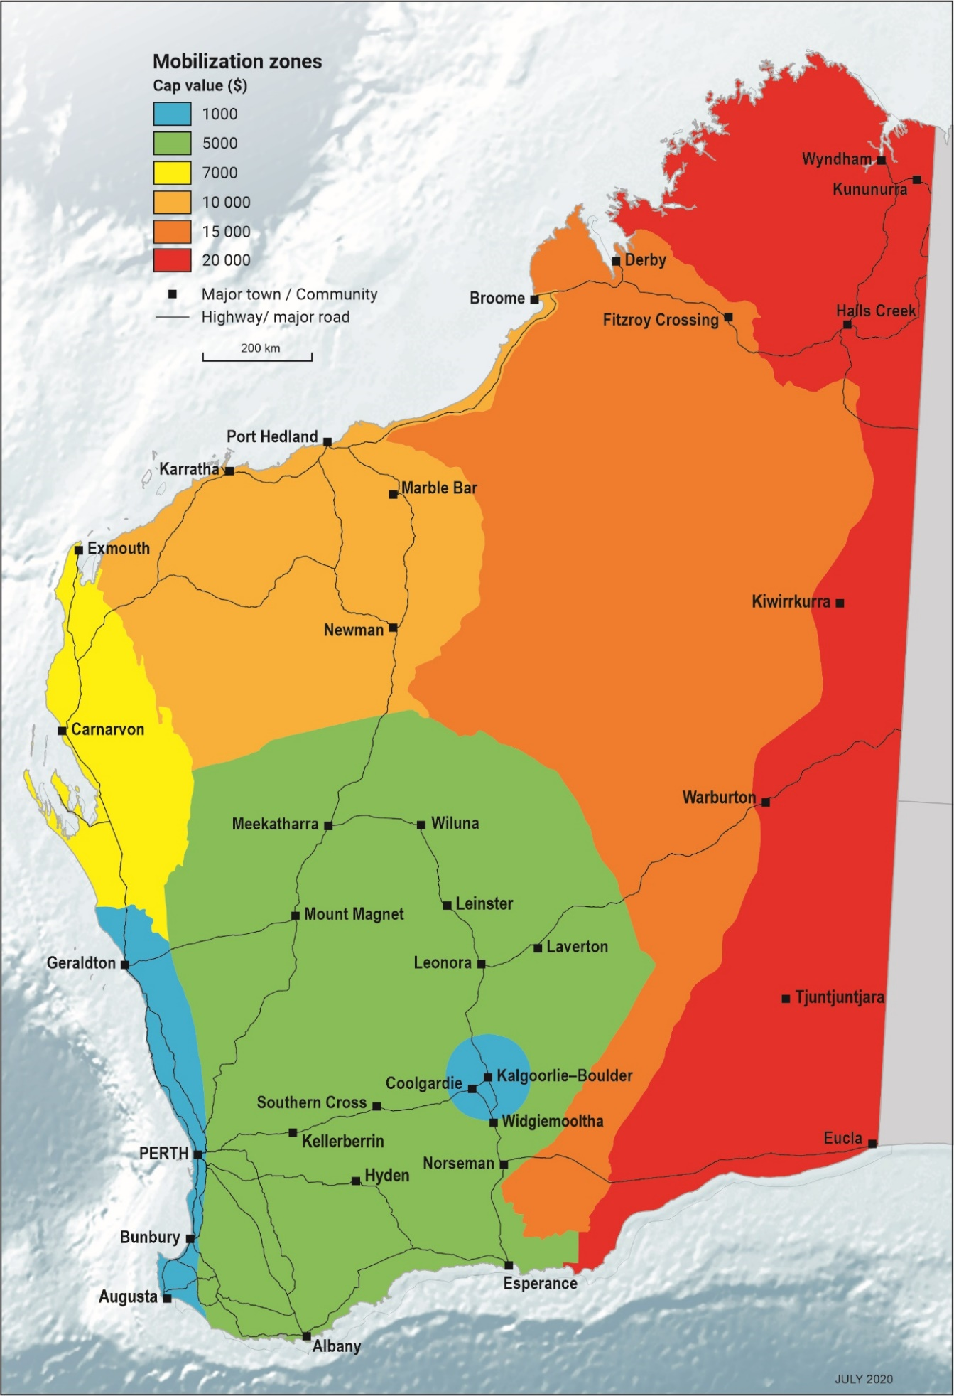

Map 1. Map of Western Australia with zones colour coded according to capped mobilization costs. GIS layers of the zones are available for download from the DMIRS website →Online Systems →Data and Software centre, under Special Category Lands.

6c. Core tray costs – diamond drilling

A new trial initiative to support exploration will be a refund on core trays purchased in order to deliver EIS co-funded diamond core, drilled as part of a successful co-funded drilling application.

The refund will be external to the calculation of direct drilling cost for a co-funded drilling application and based according to the following:

- The refund will be a maximum of $15.00 per core tray (ex GST) submitted with EIS co-funded diamond core. Where the cost per core trays is less, the refund will be based on that cost.

- An invoice from the supplier from where the core trays were purchased will need to be submitted to DMIRS. The invoice should indicate the cost per tray (ex GST).

- The refund will only be where at least ½ core is submitted in compliance with the guidelines and agreement. Where it can clearly be demonstrated that core is missing, due to post-drilling activities (i.e. other than poor recovery during drilling) such as sampling for analysis/research, there will be no refund.

- The condition and amount of the core will be checked by the core library staff once the core is delivered to either the Perth or Kalgoorlie Core library.

- The amount of $15.00 is a maximum, regardless of the core diameter. It is expected that different core sizes will be submitted in the appropriately sized core trays.

- It is expected that the core trays will be new, plastic trays. DMIRS preference is for black trays, as this assists with HyLogger scanning. However, white-coloured trays are acceptable.

- The refund will not be on any additional donated holes (non EIS co-funded) that might be drilled on the same project.

- The number of core trays should be listed on the core submission forms and will be counted by the core library staff.

- If the submission is compliant, the company/applicant will be notified by the EIS coordinator on the number of trays received and the final amount that will be refunded, prior to the final co-funding invoice being sent to DMIRS.

- The tray refund will be itemised on the final invoice, in addition to the co-funded drilling grant.

6d. Co-funded drilling and Plan for Our Parks.

In 2019, the State Government of Western Australia announced a plan to create five million hectares of new national and marine parks and conservation reserves across Western Australia.
Plan for Our Parks (PfOP) will see new and expanded parks throughout Western Australia. The areas under consideration for conservation are displayed as File Notation Areas (FNA) on the following DMIRS online databases:
- Tengraph Web
- GeoVIEW.WA (under Special Category Lands)
- Data and Software centre (under Special Category Lands)
FNA areas outlining PfOP areas can be identified under the attribute labelled ‘Purpose’, which will begin “FILE NOTATION AREA - PLAN FOR OUR PARKS – PROPOSE..”.
For example FNA 14570 reads ‘File Notation Area – Plan for Our Parks – Proposed Ningaloo Coastal Reserves – National Park’
The EIS co-funding exploration drilling program will not support applications where proposed drilling intersects a FNA with a purpose for the creation of conservation areas in the PfOP initiative (e.g. Scenario 1 in the figure below). Where a tenement may intersect an FNA for the purpose of PfOP, but the proposed drilling is completely outside of the FNA, the application will be accepted for consideration.

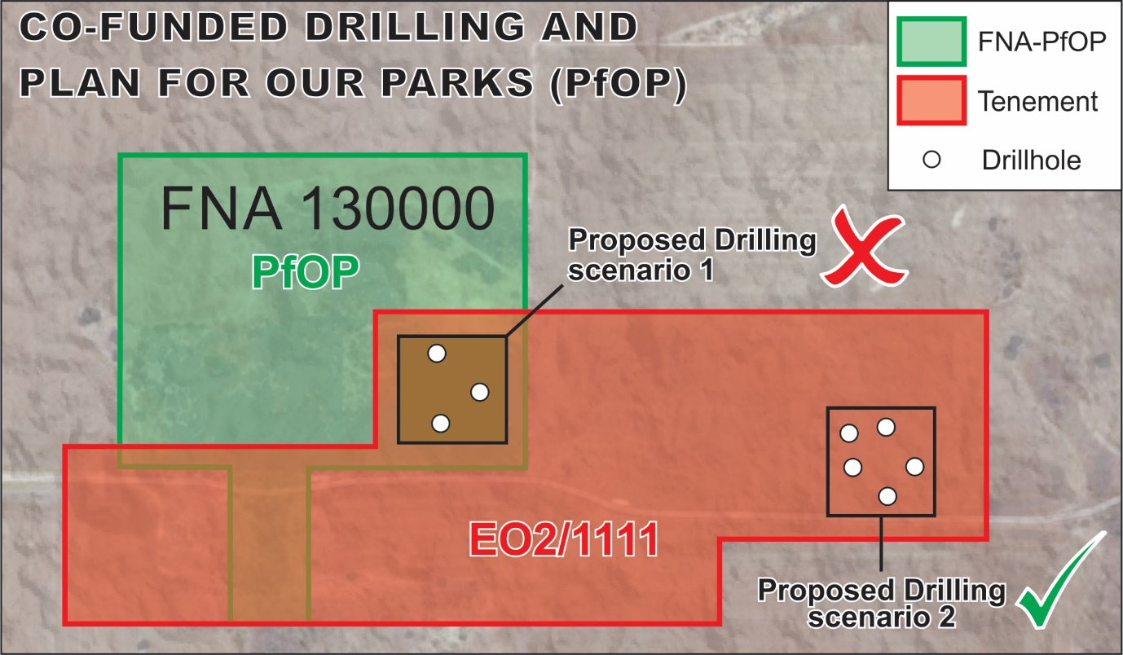

7. DOCUMENT GUIDELINES AND ASSESSMENT CRITERIA

Project Proposals must be submitted using the online application form at www.dmp.wa.gov.au/eisdrilling

APPLICATION FORM

- The online Application should be filled out as completely as possible addressing all relevant criteria.

- The drilling cost estimates should be exclusive of GST, where the Proponent is registered for GST, and is entitled to claim an Input Tax Credit on GST costs.

Proponents not registered for GST should include GST in their drilling cost estimate.

- Project Timelines for the Proposal must be realistic to ensure completion of drilling and delivery of the Interim Report and the tax invoice(s) to the Department by no later than 31 May 2023.

PROJECT DESCRIPTION - TECHNICAL ASSESSMENT CRITERIA

Proposal Documentation

Applicants should ensure that the Application conforms to the following:

- It is clear and concise;
- Images are clear and decipherable;
- A suitably annotated geological plan and predictive cross section or 3D block diagram is included showing the geochemical, geophysical geological target/s to be drilled, with a drill hole trace/s outlined.
- Relevant supporting technical data are included.

Qualitative (scored) criteria

The Application should address the Assessment Criteria in the online application form (shown below) as appropriate, although it is not expected that all Proposals will conform to every criterion.

Addresses significant knowledge gaps and/or critical uncertainties in under explored areas (i.e. general geoscientific concepts) (assessed at 75% of total value of proposal)

- Tests innovative, soundly based mineral deposit model or petroleum / energy play
- Has potential to advance exploration activity in under-explored areas
- Delivers basic geoscientific information (i.e. resolves age, stratigraphic relationships, structural settings, untested geochemical or geophysical anomalies, or depth to geophysical targets or basement, new mineral commodity in area of application)
- Program tests area of previous ineffective drilling
- Demonstrates knowledge of geology and past exploration in area of application
- Has supporting evidence for target generation (including geological plans, cross-sections, etc)

Technical Merit of Proposed Program (Assessed at 25% of value of proposal)

- Proposed methods of analysis (i.e. assays, geochronology, isotopic analysis, downhole logging, quality control etc.)
- Type of drilling (i.e. is it cored?)

Proposals which will include full assay or other specialist data in the Final report which will be released to Open File, will be viewed favourably.

Eligibility criteria

Where required, as part of the assessment process the Department will take into consideration any of following criteria which may impact on the eligibility of the Proposed Program:

Land access and corporate issues
- History in meeting tenement or title reporting/compliance commitments
- Financial and technical capacity of the proponent to undertake the proposed program
- Proposed program schedule

8. LEGAL PARAMETERS OF PROPOSALS

- Subject to Item 8(b) below, contents of all Proposals will remain confidential, except for the location of the successful Proponent’s Mining Tenement or Petroleum, or Geothermal Title.

- Although the Director General understands the need to keep commercial matters confidential in appropriate circumstances, the Director General reserves the right to disclose some or all of the contents of the Proposal so that the relevant Minister may answer questions raised in the Western Australian Parliament, keep Parliament informed or otherwise discharge the Minister’s duties and obligations to Parliament and to advise the Governor, Parliament and/or the Western Australian Government. Any condition in a Proposal that purports to prohibit or restrict the Minister’s right to make such disclosures cannot be accepted.

- Reservation of Rights - The Department of Mines, Industry Regulation and Safety reserves the right to:

  - Amend the Proposal closing date;
  - Amend the Conditions For Proposals at any time prior to the Closing Date for Proposals provided that the amendment is notified to prospective Proponents;
  - Clarify any aspect of a Proposal after the Closing Date for Proposals but before the endorsement of successful applicants by the by independent industry representatives (EIS Advisory committee);
  - Seek the advice of external consultants to assist the Director General in evaluation or review of Proposals; and
  - Abandon the process whether before or after the receipt of Proposals.

d) The Director General is not obliged to give any reasons for its selection or the abandonment of this process.

e) The Director General is not obliged to accept any Proposal.

f) No acceptance of a Proposal will be effective to constitute a contract or to create any legitimate expectation on the part of the Applicant unless a formal written agreement is executed by both parties.

g) Prior to accepting a Proposal the Director General may request additional information, including but not limited to, evidence of financial capacity.

h) The Director General, when considering a Proposal will expect that the following criteria are satisfied:

- The Applicant possesses the necessary skills, knowledge and experience to comply with the Conditions For Proposals and undertake the proposed drilling Project
- The Applicant will ensure that all land access and tenement and title security issues are resolved; and
- The Applicant is fully informed of all facts and conditions of all things relating to the Guidelines for Submission of Proposals.

i) Applicants are responsible for the cost of preparing and submitting their Proposal and all other costs arising out of the process.

j) Closing date for Application submission is Friday 4 March 2022 at 4.00 pm WST.

9. CONDITIONS OF ACCEPTANCE FOR SUCCESSFUL APPLICANTS

All successful Applicants will be required to enter into a Funding Agreement with the State of Western Australia acting through the Department of Mines, Industry Regulation and Safety.

The following principles will apply to management of funding for successful Applicants:
- Management of the successfully funded Projects will be undertaken by the Project Applicants and/or operational nominees. All liabilities associated with the Project remain with the Project Applicants.
b) Where total drilling costs for a completed Project are less than the estimate in the Proposal, the Department will provide funding in proportion to the ratio of the funding requested and the estimated total cost. A tax invoice from the Applicant, together with a concise summary of total drilling costs (including copies of tax invoices from drilling contractors) must be provided to the Director General.
c) Drilling must be conducted according to land access and environmental procedures for Western Australian mining tenements or petroleum, or geothermal titles (refer to the website of the Department for details).
d) Interim payment schedule:
- Will be 80% of the agreed Government (drilling) co-funding funds;
- The tax invoice and Interim Report must be submitted by the successful Applicants to the Director General within two weeks of the completion of drilling and in any case, no later than 31 May 2023.
- Final payment will be made on submission of core and acceptance of the Final Report containing all technical information directly relevant to the drilling Project which should be submitted 3 months after the completion of the drilling and in any case no later than 31 August 2023.
e) Details of the interim and final drilling reports and all deliverables will be defined in the Funding Agreement between the successful Applicant and the Department.
f) Drilling assistance funding contributions from the Department cannot be included as part of company expenditure commitments for Mining Tenements, or Petroleum, or Geothermal Titles.
g) Drilling must be undertaken by a third party, whereby submitted drillers invoices show a different company name, address and ABN from the successful applicant awarded the EIS co-funded drilling.

All results, including drill sample material, are to be made Open File after a maximum confidentiality period of six months (commencing after payment of the first invoice).

All deliverable data must be provided in the standard data formats for reporting results from mining tenements, or petroleum, or geothermal titles as required by the Department (these are available on the Department’s website: www.dmirs.wa.gov.au). Drill core samples are to be lodged with the Department’s Core Library on completion of the Final Report.

10. FINAL REPORT SUBMISSION AND FURTHER INFORMATION

The Final Report must be received within 3 months of submission of the Interim Report.

The Report must be received no later than 5 pm WST on 31 August 2023.

Reports are to be submitted online, using the WAMEX Report Lodgement system at http://www.dmp.wa.gov.au/WAMEX-Minerals-Exploration-1476.aspx

Enquiries should be directed to:

Dr Charlotte Hall
Coordinator Exploration Incentive Scheme
Department of Mines, Industry Regulation and Safety
100 Plain Street
EAST PERTH, WA 6004

Phone: +61 8 9222 3410
charlotte.hall@dmirs.wa.gov.au
APPENDICES 1 to 4

(HYPERLINKS TO DEPARTMENTAL GUIDELINES)

APPENDIX 1

Environmental guidelines (petroleum and mineral exploration)

http://www.dmp.wa.gov.au/Environment/Guidelines-and-guidance-19754.aspx

APPENDIX 2

Drill core guidelines (includes core submission form)

http://www.dmp.wa.gov.au/Documents/Geological-Survey/Core_Submission_ABBREV_Jan%2017.pdf

APPENDIX 3

Guidelines for mineral exploration reports

http://www.dmp.wa.gov.au/News/Guidelines-for-mineral-24361.aspx

APPENDIX 4

Guidelines for petroleum and geothermal exploration reports

http://www.dmp.wa.gov.au/Petroleum-and-Geothermal-1497.aspx

