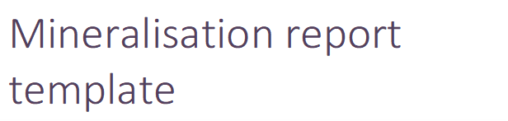

MINERALISATION REPORT AS REQUIRED BY SECTION 74(1)(ca)(ii)
OF THE MINING ACT 1978 (AS AMENDED)

MINERALISATION REPORT TO SUPPORT A MINING LEASE APPLICATION
WITHIN EXPLORATION LICENCES Exx/xxxx and Exx/xxxx

MINING LEASE APPLICATION NUMBER

Commodity: XXXX

Name of qualified person
Select membership. Add membership number
Company Name
Click or tap to enter a date of this report.

Contents
1 Statement of deposit 3
2 Location 4
3 Geology 5
4 Mineralisation 6
5 Additional information 10
6 Qualified person statement 11

Disclaimer
This report has been prepared in accordance with Section 74(1)(ca)(ii) of the Mining Act 1978, which is included below; a mineralisation report is defined as a report that sets out details of exploration results in respect of a deposit of minerals located in, on or under the land to which the application relates, including details of —
- the type of minerals located in, on or under that land; and
- the location, depth and extent of those minerals and the way in which that extent has been determined; and
- analytical results obtained from samples of those minerals;
The mineralisation report is required to be prepared by a qualified person. Under the Mining Regulations 1981 a ‘qualified person’ means a person who is a member of the Australasian Institute of Mining and Metallurgy (AusIMM) or the Australian Institute of Geoscientists (AIG).

Statement of deposit of minerals
A statement that a deposit of minerals has been defined within the boundaries of the area applied for and the results of exploration activities indicate that there is a reasonable expectation that mining operations can be undertaken to extract minerals. In most cases this area will be within an existing prospecting or exploration licence and the relevant underlying tenement number(s) should be quoted.
For example
Company XXX has prepared this mineralisation report in accordance with Section 74(1)(ca)(ii) of the Mining Act 1978 to accompany the supporting statement for a Mining Lease Application (“MLA”) within whole/part of Exx/xxxx and Exx/xxxx.
The MLA is being applied for by company XXX who is the registered holder of Exx/xxxx and Exx/xxxx.
Company XXX has identified significant commodity within the boundaries of the area applied for and the results of exploration activities indicated there is a reasonable expectation that mining operations can be undertaken to extract the commodity.
The proposed mining lease covers the XXX, located to the XXX and, located approximately XXkm XXXX of XXXX of Western Australia.
For commodity, a complete list of minerals that have been defined within the deposit should be stated. Under the Mining Act 1978 the term ‘minerals’ means naturally occurring substances obtained or obtainable from any land by mining operations carried out on or under the surface of the land

Location
A plan showing the outline of the deposit of minerals (projected to the surface as a polygon), the boundaries of the existing tenement(s) (where applicable), and the proposed boundaries of the mining lease application.
For example
The MLA area covers P16/2791 which is located approximately 60km northwest of Kalgoorlie (Figure 1). This places the tenement within the Coolgardie Mineral Field, and within the Kalgoorlie (SH51‐09) 1:250 000 and Kalgoorlie (3136) 1:100 000 map sheet areas.
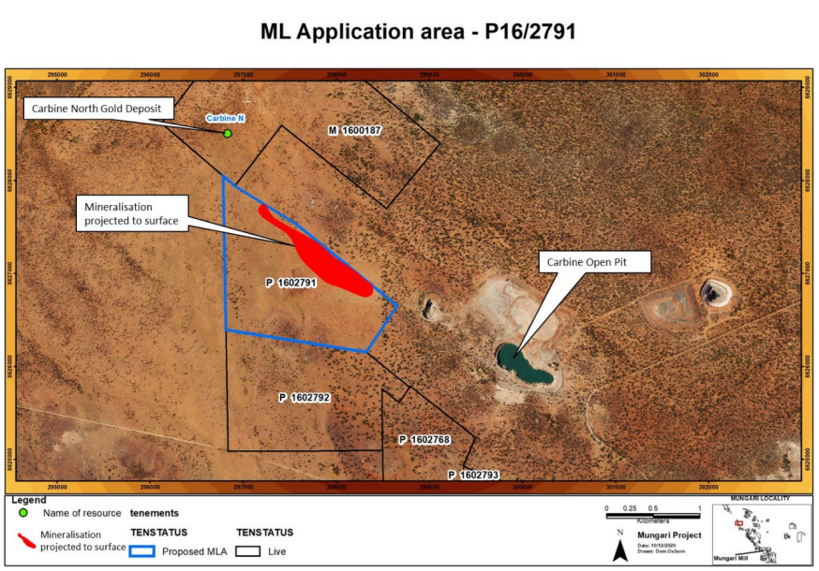
Figure 1. Plan map showing mineralisation outline projected to surface, existing tenement boundaries, and proposed boundary of MLA.

Geology
The background geology does not need to be extensive, but sufficient to place the mineralisation in context.
For example
The bedrock geology of the Corboys Project area comprises a north-northwesterly trending greenstone sequence dominated by interlayered basalt and dolerite with minor ultramafic, banded iron-formation and felsic volcanic/volcaniclastic sediments. The greenstones are intruded by porphyritic granitic dykes of uncertain age and Proterozoic dolerite dykes. This sequence is inferred to host the northern extremity of the north-south trending Ockerburry Fault System and is bound to the west by a regional monzogranite. The interpreted bedrock geology of the project area and surrounds is shown in Figure 2.
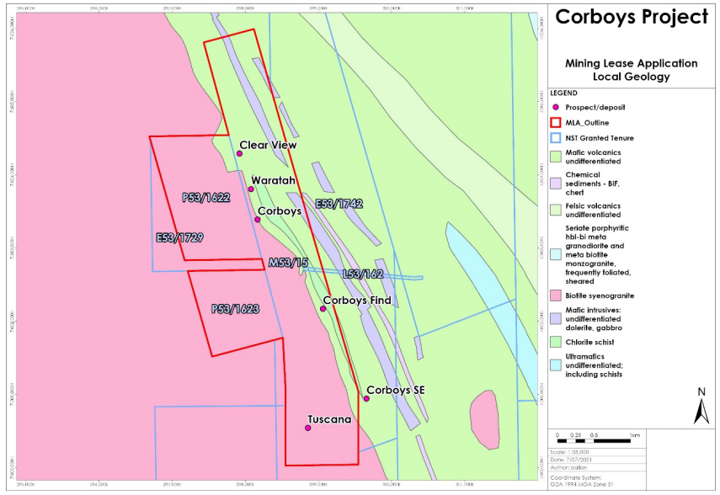
Figure 2. Interpreted bedrock geology of the Corboys project, with the MLA location and underlying tenure shown.

Mineralisation
This is the main component of the report and all content should be clear and concise. It is a critical requirement that the location of the minerals present, including their depth and extent is clearly described and illustrated. This shall be a standalone report containing all relevant information that is to be assessed by the Director, Geological Survey. The report and the supporting statement shall become available to the public when they have been submitted to the Department of Mines Industry Regulation and Safety. The methods used to define the zone of mineralization should be clearly outlined (e.g. drill intersections, costean channel sampling, old adit sampling, etc.). The methods may include data/ work undertaken by previous tenement holders of the same ground. This section must include a plan showing the outline of the deposit of minerals (projected to the surface) and the positions of all drill holes, costeans, adits, etc. that have intersected the deposit. The plan should also show the locations of at least two representative cross sections (or one cross section and one long section). If multiple mineral deposits are defined then at least two representative cross sections (or one cross section and one long section) should be provided for each deposit. The plan labels and legend must be clearly legible.
For example
Gold mineralisation occurs as a sub-horizontal “redox blanket” associated with the base of complete oxidation (BOCO). Drilling indicates that the favourable horizon occurs between 50 - 70m and varies in thickness between 5 -10m. BOCO related mineralisation can be as shallow as 24 - 28m, with some locally thickened regions >20m (see cross section 3 in Figure 4). Average gold grade varies between 0.3 – 1.0g/t Au, with localised zones of much higher grades (Figure 3 and Table 1). At depth, economic gold grades have been intersected in highly sheared and altered saprock and fresh rock intervals (e.g. RRLCMRC034 – Figure 4).
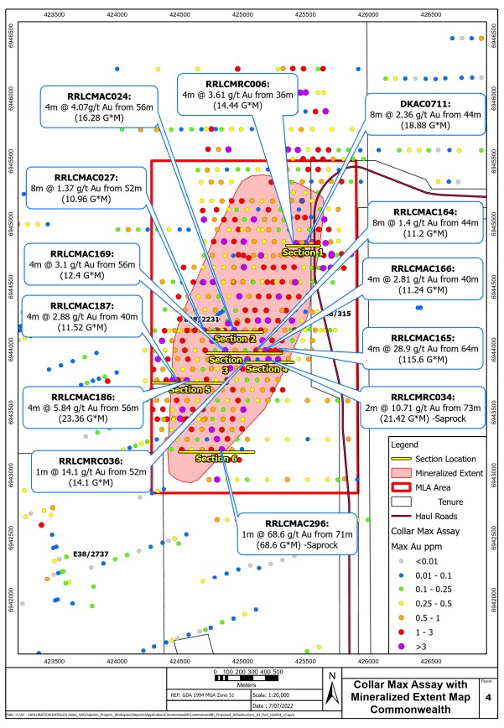
Figure 3. Plan showing proposed MLA, underlying tenure, mineralised zone projected to surface, cross section locations, drillholes locations, and callouts for significant intersections.
Cross sections/long sections (with drill profiles and/or costean outlines) to show intersections of mineralisation and its host rocks, together with analytical results in a generalised format (i.e. showing bulked intersections with average grades). Drill hole labels and legend must be clearly legible on cross sections. It is critical that depth and extent of mineralisation is clearly demonstrated.
For example
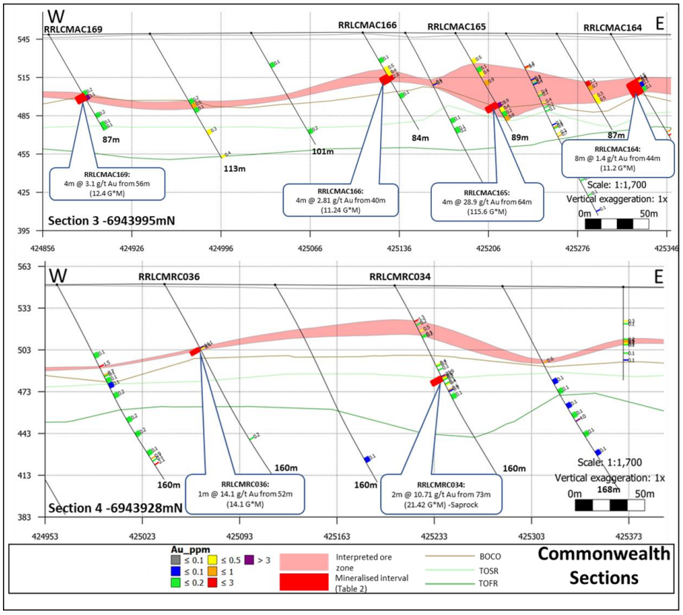
Figure 4. Accompanying cross sections showing associated drillholes with names, significant intersections, and interpreted ore zone.

A table of analytical results and brief discussion in the text to demonstrate the existence of significant grades and widths of mineralisation. These may include earlier results obtained by previous tenement holders of the same ground. The table should as a minimum include only those drillholes (and/or costeans and/or adits) that appear on the plan referred to in Figure 3. The table should include drillhole names, collar coordinates, depth to significant intersection, width of significant intersection, and grade. A description of sampling techniques, drill sample methods and recoveries, and quality of analytical data for all samples would be beneficial. The table should be accompanied by mineralisation cut-off grades where mineralisation zones are represented by averaged results. In the case of certain industrial minerals the results should include analyses of the physical properties which demonstrate that the deposit can be economically extracted.
For example
Table 1. Drillholes with significant gold intercepts (>1g/t).
Hole_ID | Hole Type | mE | mN | mRL | Dip | Azimuth | Depth(m) | From(m) | To(m) | Interval(m) | Au g/t
SRC216 | RC | 746569 | 6882487 | 464 | -60 | 90 | 259 | 223 | 224 | 1 | 1.18
SRC218 | RC | 746491 | 6882570 | 466 | -60 | 90 | 294 | 68 | 71 | 3 | 3.80
 |  |  |  |  |  |  |  | 222 | 228 | 6 | 1.65
 |  |  |  |  |  |  |  | 243 | 247 | 4 | 1.09
SRC219 | RC | 746468 | 6882810 | 466 | -60 | 90 | 90 | 39 | 40 | 1 | 1.71
 |  |  |  |  |  |  |  | 58 | 59 | 1 | 2.74
 |  |  |  |  |  |  |  | 59 | 61 | 2 | 1.46

Ensure all maps/ figures are well presented and all map elements are clearly legible.
The maps should show basic elements such as coordinates, coordinate system, legend title, location, date prepared, and author.
The highest resolution is recommended to ensure data quality, e.g. 300 dpi.
Figures do not need to be imbedded in the report and can be collated into the final .pdf file.

Additional Information
Additional information that an applicant may wish to submit, to further support the existence of a deposit of minerals and the intention to extract those minerals, for example:
- Proposed program of work and expenditure to be undertaken to increase the level of geological knowledge and confidence of the deposit of minerals after the proposed mining lease is granted
- Metallurgical test results
- Bulk densities of mineralised material
- Geotechnical characteristics of the deposit of minerals and its host rocks
- Potential penalty or credit elements or minerals
For example
Table 2. Planned drill program to produce a mineral resource estimate.
Planned Hole ID | Easting | Northing | RL | Depth | Azimuth | Dip
Id 00001 | 746450 | 6882730 | 468.717 | 160 | 90 | -60
Id 00002 | 746410 | 6882730 | 469.103 | 200 | 90 | -60
Id 00003 | 746370 | 6882730 | 468.896 | 250 | 90 | -60

Must have appropriate information to be able to assess the program.

Qualified person statement
The information in this report relates to information compiled and reviewed by XXXX, who is an employee of Company XXXX. Qualified person XXXX is a member of the Australasian Institute of Mining and Metallurgy and/or a member of the Australian Institute of Geoscientists. Qualified person XXXX consents to the inclusion in this report of the matters based on information in the form and context in which it appears.

Signature of qualified person
Click or tap to enter a date of this report.

