Guidelines for Submission of Applications for the Co-funded Geophysics Program

8 November 2023

Contents
1. About the program 3
2. Important dates 5
3. Funding sequence 6
4. Definitions 7
5. Eligibility criteria 8
5.1 Applicant eligibility 8
5.2 Project requirements 8
5.3 Claimable costs 10
5.4 Multiple applications 10
5.5 Projects covering multiple tenements 11
5.5.2 Airborne 11
5.5.3 Ground-based 11
6. Application process 12
6.1 Applying online 12
6.2 Assessment process 12
6.3 Endorsement of panel assessment pre-selection 13
6.4 Notification 13
7. Successful applicants 13
7.1 Funding Agreement 13
7.2 Fieldwork 14
7.3 Withdrawal 14
7.4 Deliverables 14
7.4.1 Geophysical data 15
7.4.2 Final report 15
7.4.3 Tax Invoices 15
7.5 Project completion 15
8. Contact details 16
Appendix 1. 17
Appendix 2. 18

1. About the program

The Co-funded Geophysics Program (CGP) is competitive program funded by the Western Australian State Government through the Department of Mines, Industry Regulation and Safety’s (DMIRS) Exploration Incentive Scheme (EIS). The CGP aims to provide new information on greenfields regions of the State for exploration of new mineral deposits including; refining regional structures including basin or province margins, identifying geophysical anomalies under cover, and redefining regions for new deposit types.
The CGP will support geophysical exploration in the mineral resources sector. Higher preference will be given to:
- Greenfields projects (exploration in unexplored or under explored areas, away from known deposits or mines).
- Regional to camp-scale projects (see definitions, section 4).
- Projects targeting critical minerals (see Appendix 1).
The EIS will allocate approximately $2 million per year to the Co-funded Geophysics Program. The co-funding amount will be 50% of the actual costs (see section 5.3) up to a capped value of $250,000 per project.
Each application period will be referred to as a ‘Venture’, e.g. Venture 1 Co-funding June 2024 – May 2025. There will only be one application process/venture per year, with the funding term coinciding predominantly with a financial year.

Each application period will have a specific area from which it will accept applications – the Venture Release Area (Figure 1). The Co-funded Geophysics Program for 2024-2025 – Venture 1 – will accept applications from Release Area 1 (Figure 1).

Figure 1. Venture Release Areas – Venture 1, 2024-2025 accepting applications from Release Area 1

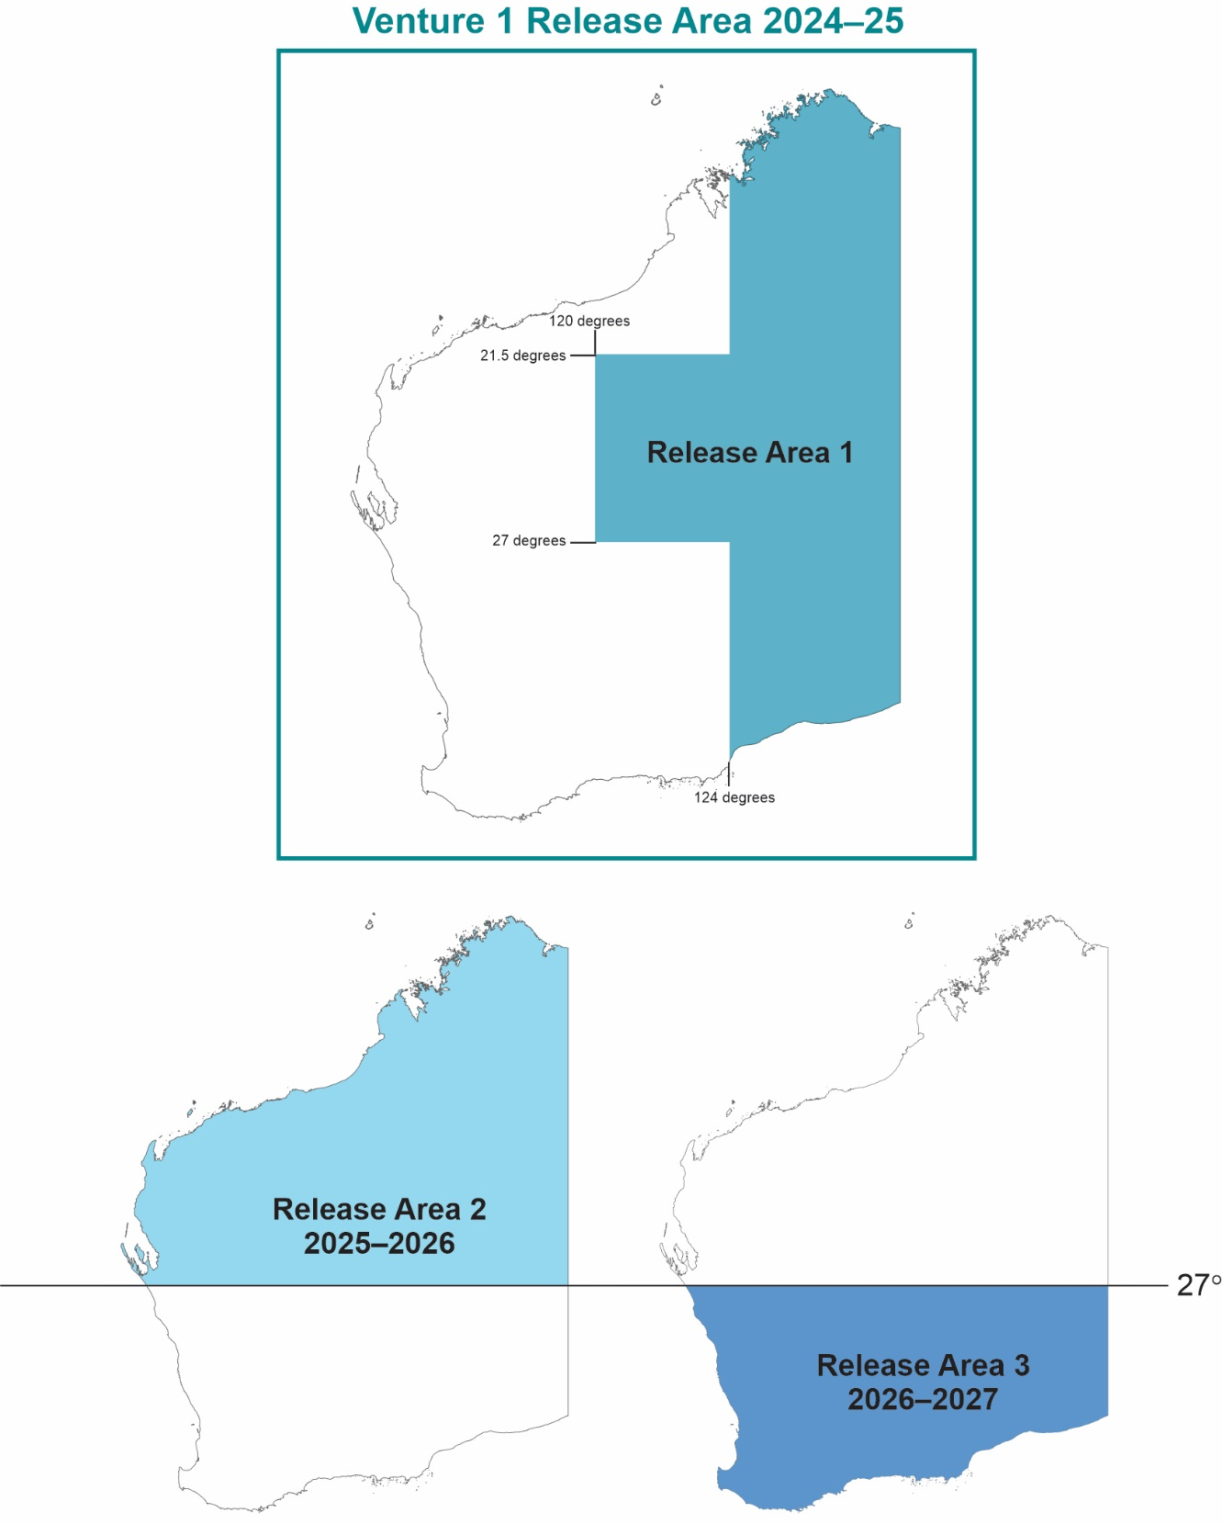

2. Important dates
IMPORTANT NOTE: The CGP will only open for applications ONCE a year.
DATE | EVENT
5 February 2024 | Applications open (online)
1 March 2024 | Applications close (4 pm WST deadline)
Mid-April 2024 | Planned announcement of successful proposals
By 31 May 2024 | Agreements fully executed: signed by Applicants and DMIRS
1 June 2024 –31 May 2025 | Term of Funding Agreements for 2024–25 Co-funded Geophysics Program
31 May 2025 | Last date for acceptance of final reports, data and invoices for 2024–25 projects (5 pm WST deadline).

3. Funding sequence
APPLICATIONS OPEN
5 February 2024 – 1 March 2024

Assessment

Notification and announcement of successful Applicants
Mid-April 2024

Funding Agreement fully executed
By 31 May 2024

Funding Term commences
1 June 2024

Data acquisition/processing undertaken

Submission of report, data and invoices for DMIRS approval
By 31st May 2025

50% co-funding invoice paid
On approval of submission items
(payment maybe after funding term ends*)
Funding Term ends (no extensions)
31 May 2025

Project deliverables OPEN FILE three months after Funding Term ends.
1 September 2025

NOTE: Projects must be completed and a final geological project report, geophysical data submission, company invoice and survey provider’s tax invoice, delivered to the EIS Coordinator, Geological Survey of Western Australia, Department of Mines, Industry Regulation and Safety by 31 May 2025. No extension beyond this date is allowable. * Provided the report, data and invoices are submitted before the funding term ends.

4. Definitions

“Director General” means the Director General of the Department of Mines, Industry Regulation and Safety.
“Minister” means the Minister for Mines and Petroleum.
“Applicant” means the company, institution or individual submitting a proposal.
“Funding Agreement” means the agreement of conditions of funding grant between the parties. These Guidelines form part of the Funding Agreement.
“Funding Term” means the period from the Commencement Date until the Completion Date (inclusive of those dates).
“Proposal” means the documentation prepared and submitted to the Director General in an application for Government - Industry Geophysics Co-funding.
“Project” means the work undertaken by the successful Applicant in accordance with the Proposal.
“Closing Date” means 4 pm WST on the 1 March 2024. This is the last day to submit a proposal. The online submission of the application must be completed at this time.
“Commencement Date” means 1 June 2024.
“Completion Date” means 31 May 2025.
“Geophysics Co-funding” means monies/refund distributed to successful applicants on completion of projects.
“Mining Tenement” means the area (or part thereof) outlined in the Proponent’s licence or lease granted under the Mining Act 1978 (WA).
“The Department” means the Department of Mines, Industry Regulation and Safety (DMIRS).

“Greenfields” means exploration activity in unexplored or underexplored areas, away from known deposits or mines, where target architecture is poorly understood/defined.
“Brownfields” means exploration in the vicinity of an operating mine, or a deposit with an existing Identified Resource, with the purpose of growing the resource base in an area of known endowment.
“Identified Resource” means a JORC-compliant or equivalent mineral resource of Inferred status or higher (comparable to definition from Australia’s National Classification System for Identified Mineral Resources).
“Regional-scale” means projects that assess the potential of a whole basin/belt/arc/district to host a mineral resource.
“Camp-scale” means projects that assess a specific area within a basin/belt/arc/district for mineral target(s).
“Prospect-scale” means exploration of a specific single or tightly clustered mineral target(s).
“Target” means a site where mineralisation could conceptually be found based on geochemical or geophysical anomalies, or geological setting.

5. Eligibility criteria

5.1 Applicant eligibility
The Applicant is a legal entity that can enter a legally binding Funding Agreement with the WA Government, has an active Australian Company Number, and is registered for GST.
The Applicant must hold a granted tenement/s in the State of Western Australia (see Table 1). Applications on pending tenements will not be accepted.
Table 1. Tenement status accepted and excluded from co-funding.
 | Mining | Comment
Accepted | Granted tenement
Not Accepted | Pending tenement | As at the time of application submission.

The Applicant must provide a quote showing the estimated project cost and indicating the availability of the contractor to conduct the survey within the Funding Term.
All quotes will be treated as Commercial in Confidence information.
Where required, as part of the assessment process the Department will take into consideration any of following criteria which may impact the eligibility of the proposal:
- History in meeting reporting/compliance commitments to the Department
- History in meeting reporting/completion commitments to previous EIS programs
- Financial and technical capacity of the Applicant to complete/undertake the proposed program.

5.2 Project requirements
Project activities must comply with the Mining Act 1978 (WA).
Mine site, borehole scale, and 3D seismic projects are not eligible for funding (see Table 2).
Table 2. Geophysical survey types eligible for co-funding (see Appendix 2 for examples).
Eligible Geophysical Surveys | Ineligible Geophysical Surveys
Ground-based surveys  Airborne surveys | Mine site surveys  Borehole surveys  3D active seismic surveys
Projects cannot be retrospective and can only begin when the successful applicants have been publicly announced, the Funding Agreement has been fully executed, and on or after the Commencement Date.
Data acquisition and processing costs claimed for the grant must be undertaken and invoiced by an independent third party (contractor/supplier) with a different company name, ACN and business address, to that of the applicant.
Acquisition and processing may be undertaken by different third party suppliers. All contractors/suppliers must provide invoices for work undertaken within the funding period.
Before applying, the Applicant should ensure that all land access, tenement, and heritage issues are resolved. Where appropriate, a current Indigenous Land Use Agreement (ILUA) is seen as favourable.
Proposals must be conducted on a tenement/s within the Venture Release Area for the Venture (Figure 1), this can also be viewed on the Co-funded Geophysics website: Co-funded Geophysics Program (CGP) (dmp.wa.gov.au)
If a tenement falls across the boundary of the Venture Release Area, it is still eligible provided the majority of the survey and target occurs within the Venture Release Area (Figure 2).
Figure 2. Geophysical program with a target falling within the Venture Release Area and outside of the Venture Release Area.
SUPPORTED NOT SUPPORTED
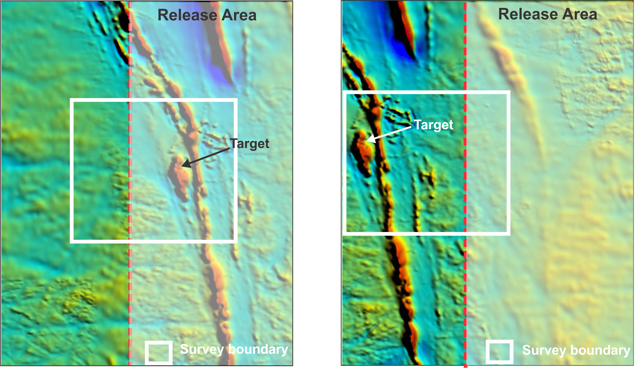

5.3 Claimable costs
Co-funding is available for up to half (50%) of the direct program costs, but no more than the offered amount. Where 50% of the direct program costs are more than the funding offer, the co-funding amount will be the funding offer. All eligible costs must be itemised on the contractors invoice(s).
Direct program costs include activities or items specifically required for the satisfactory completion and delivery of the proposed project to industry accepted standards.

Direct costs
- Survey acquisition cost; invoices charged by geophysical contractors for active work and consumables.
- Mobilisation (up to 5% of the project cost invoiced to the Department)
- Data processing
Costs not funded
- Standby (e.g. weather, waiting on parts)
- Applicant personnel costs (e.g. company geologist salary)
- Administration costs (e.g. heritage surveys and ground clearances)

5.4 Multiple applications
A maximum of two applications may be submitted by a single Applicant/Company. There will be no handicapping of second applications, however, two applications by the same company over the same area are not seen as favourable. Where a company chooses to submit two applications over the same area, it must be clearly demonstrated that the undertaking of the project in one application is not contingent on the completion and results of the project in the company’s other, separate, application.
If more than two applications are submitted by a single Applicant/Company the Department will request (by email) that the company choose two projects to remain active and proceed through the assessment phase. If the Applicant/Company does not provide a response before the date designated by the Department in the request, the applications (2) with the highest marks will remain eligible and the application(s) with lower mark(s) will be made ineligible.
An application should be limited to one type of geophysical survey, unless two forms of data will be collected in a single survey, e.g. airborne magnetics and radiometrics.
Applicants can apply to multiple EIS co-funding programs at the same time e.g. Co-funded Exploration Drilling Program. Applications across different co-funding programs will be treated on individual merits of the applications, not co-jointly.

5.5 Projects covering multiple tenements
5.5.1 General conditions
Where two or more companies form an agreement to undertake a single survey across the tenement holdings, there can be only one company listed as the Applicant/Company.
The designated Applicant/Company is the company that enters into the agreement with the Department and is;
- Responsible and liable for all project conditions as outlined in the Funding Agreement, including deliverables to the Department; reports, data, and invoices.
- The only company that may invoice the Department for co-funding.
- Is the only company that any eligible grant payment is made to.

The Department takes no responsibility for the arrangements made between the participating companies over which the survey takes place.

The Department takes no responsibility for any disputes that may arise between participating companies.

5.5.2 Airborne
Airborne projects may cover multiple tenements, however, there can be only ONE Applicant/Company per application (see above).

5.5.3 Ground-based
Ground-based projects may cover multiple tenements, however, there can be only ONE Applicant/Company per application (see above)
If the Applicant is not the holder of the tenement on which a ground-based survey is planned, then a letter of agreement is required from the tenement holder and should be attached to the Co-funded Geophysics Program application.
Where a project area covers multiple tenements with different tenement holders, a letter of agreement is required from each tenement holder and should be attached to the Co-funded Geophysics Program application.

6. Application process

6.1 Applying online
Complete the Application form online, accessible at the EIS Co-funded Geophysics Program homepage: Co-funded Geophysics Program (CGP) (dmp.wa.gov.au)
Each application will require:
- Administrative information about the applicant (Name, ACN, business address)
- Contact details for the primary company person with whom the Department will correspond with
- Project details - survey type, basic survey details as applicable (area, line km’s, line spacing, number of stations)
- A quote of the estimated project cost and funding requested for project
- Indication of the survey providers’ availability to conduct the program and proposed start date
- A project description which addresses the technical assessment criteria within the online application. This should include figures, tables and maps to support the application.
For ground-based activities, an indication that the Aboriginal Cultural Heritage Act and Management Codes have been reviewed/considered.
- Attachments
    - GIS format files of proposed survey boundaries (mandatory)
    - Survey provider quote and indication of availability (mandatory)
    - Tenement holder agreement/s (if applicable)

6.2 Assessment process
All applications will be assessed by an expert panel of officers from the GSWA and independent industry specialists.
The panel will use the predefined assessment criteria specified in the online application.
The assessment will focus on the technical merits of the project and its capacity to broaden geological knowledge in greenfields areas of WA.
All decisions made by the panel will be final with no right of appeal.

6.3 Endorsement of panel assessment pre-selection
Endorsement of the panel’s assessments and pre-selection of successful applicants will be overseen by a co-funding Advisory Panel, consisting of members from industry bodies and DMIRS. This will be the same panel that oversees the other co-funding projects. The panel currently has representatives from AMEC, CMEWA, academia and senior officers of DMIRS (e.g. ED of the GSWA and a Deputy Director General of DMIRS)
All decisions made by the panel will be final with no right of appeal.

6.4 Notification
On completion of the assessment process, all Applicants will be notified of the outcome of their application via email immediately after the Minister for Mines and Petroleum releases a media statement of the successful applicants. Successful Applicants will be formally notified in writing and of the date of the compulsory briefing.

7. Successful applicants

7.1 Funding Agreement
All successful Applicants will be required to enter into a Funding Agreement with the State of Western Australia acting through the Department of Mines, Industry Regulation and Safety.

The following principles will apply to management of funding for successful Applicants:
- Management of the successfully funded projects will be undertaken by the Project Applicants. All liabilities associated with the project remain with the Project Applicants.
- Where 50% of claimable costs for a completed project are less than the Refund amount as stated in the Letter of Offer, the Department will provide funding in proportion to the ratio of the funding requested and the estimated total cost. A tax invoice from the Applicant, together with a concise summary of total costs (including copies of tax invoices from analysis contractors/providers) must be provided.
- Geophysical projects must be conducted according to land access, heritage, and environmental procedures for Western Australian mining tenements.
- A single invoice payment will be made on submission and acceptance of the project deliverables as defined in 7.4.
- Geophysics co-funding contributions from the Department cannot be included as part of company expenditure commitments for mining tenements.
- Geophysical survey acquisition must be undertaken by a third party, whereby submitted contractor invoices show a different company name, address and ACN from the successful applicant awarded the EIS co-funding.

7.2 Fieldwork
Any changes to the project must be submitted to the EIS coordinator in writing and granted approval before being undertaken. A change of project deliverables may invalidate the Funding Agreement.
Upon commencement and completion of field work, the date of commencement and completion should be emailed to the EIS coordinator.

7.3 Withdrawal
Should the Applicant wish to withdraw from the Funding Agreement they are requested to notify the EIS Coordinator in writing before the end of the Funding Term. The notification should also include a general reason for the withdrawal.

7.4 Deliverables
The deliverables required for each project are:
  - Final Report containing all technical information directly relevant to the project, submitted through WAMEX.
  - Complete raw and processed data packages submitted through the MAGIX portal.
  - Invoices, from the applicant (for co-funding) and survey supplier (showing project costs) submitted by email to the EIS coordinator
All deliverables must be provided in the standard data formats for reporting results from mining tenements as required by the Department (these are available on the Department’s website: www.DMIRS.wa.gov.au).

7.4.1 Geophysical data
Geophysical data should be lodged through the Department’s MAGIX portal.
  - Applicants should apply to ‘Register a Survey’ and upload their data directly into the MAGIX system.
  - A survey number will be allocated. This number should be quoted in the final report submission into WAMEX.
  - To register a survey, enter MAGIX MAGIX (DMIRS.wa.gov.au) and select “Data Submission’ tab. Applicants may need to create an account.

7.4.2 Final report
The final project report should be submitted online through the WAMEX Report Lodgement system quoting the relevant MAGIX survey number. http://www.dmp.wa.gov.au/WAMEX-Minerals-Exploration-1476.aspx

7.4.3 Tax Invoices
The applicant tax invoice and third party service provider invoices should be submitted by email to the EIS coordinator.

7.5 Project completion
Submission of final report, data and invoices MUST be before the completion date.
The final invoice will be paid post submission and DMIRS approval of all project deliverables as outlined in the Funding Agreement.
All reports and data will become open file three months after the conclusion of the Funding Term.
Projects submitted and finalised before the conclusion of the Funding Term will remain confidential until three months after the conclusion of the Funding Term.

8. Contact details
Enquiries should be directed to:
Dr Charlotte Hall
Coordinator Exploration Incentive Scheme
Department of Mines, Industry Regulation and Safety
100 Plain Street
EAST PERTH, WA 6004
Phone: +61 8 9222 3410
charlotte.hall@DMIRS.wa.gov.au

Secondary Contact
Louisa Collins
100 Plain Street
EAST PERTH, WA 6004
Phone: +61 8 9222 3768
louisa.collins@DMIRS.wa.gov.au

Appendix 1. Australia’s critical minerals and WA Future Battery minerals
High-purity Alumina
Antimony
Beryllium
Bismuth
Chromium
Cobalt
Gallium
Germanium
Graphite
Hafnium
(Helium)*
Indium
Lithium
Magnesium
Manganese
Niobium
Nickel
Platinum-group elements (PGE)
Rare-earth elements (REE)
Rhenium
Scandium
Silicon
Tantalum
Titanium
Tungsten
Vanadium
Zirconium

* Excluded. This program is for mineral exploration and requires a granted mining tenement. In Western Australia, helium (a hydrocarbon gas) is managed under the Petroleum and Geothermal Energy Resources Act 1967 (WA), which deals with petroleum titles.

Appendix 2. Examples of geophysical survey types eligible for co-funding, airborne and ground. This list is not exclusive, new techniques will be considered with good supporting documentation.
Survey type | Sub-categories
Magnetics
Gravity | Gravity
 | Gradiometery
Radiometric | Gamma ray spectrometry, gamma ray scintillometry
Electrical | Electromagnetic (EM)
 | VLF EM Surveys (very low frequency)
 | Horizontal Loop HLEM Surveys (Vertical loop)
 | Time-domain EM Surveys (VTEM, TEM, TDEM, Geonics EM37, Crone Pulse EM, UTEM)
 | Frequency-domain electromagnetics (FEM)
 | Induced polarization (IP) – collected by electrical profiling
 | Electrical Resistivity (Resistivity) 1D, 2D, 3D and 4D forms
 | Magnetotellurics (MT) – form of EM
Seismic | 2D Active (reflection and refraction)
 | Passive (ambient noise tomography, body wave tomography)
Self Potential (SP)
Remote Sensing (general term) includes; | LANDSAT, Advanced Spaceborne Thermal Emission and Reflection Radiometer (ASTER), Light Detection and ranging (Lidar), sonar, radar, ground penetrating radar (GPR), hyper spectral, field spectroscopy, thermal infrared.
Multi-channel analyses of surface waves (MASW)
Natural Magnetic Resonance (NMR)

