Area L19-2

Release Summary
Petroleum Acreage Release 1 of 2019 – Area L19-2
Released: Tuesday 10 December 2019
Closed: Thursday 9 April 2020
Areas available: Petroleum and Geothermal Energy Resources Act 1967
Area: L19-2
Graticular blocks:
1:1,000,000 Hamersley Range Map Sheet (SF50)
Block No | Block No | Block No | Block No | Block No
5812 | 5813 | 5882 | 5883 | 5884
5885 | 5886 | 5953 | 5954 | 5955
5956 | 5957 | 5958 | 6025 | 6026
6027 | 6028 | 6029 | 6097 | 6098
6099
Contains 21 blocks to the extent only that the area is within the State as defined in section 26 of the PGERA67.
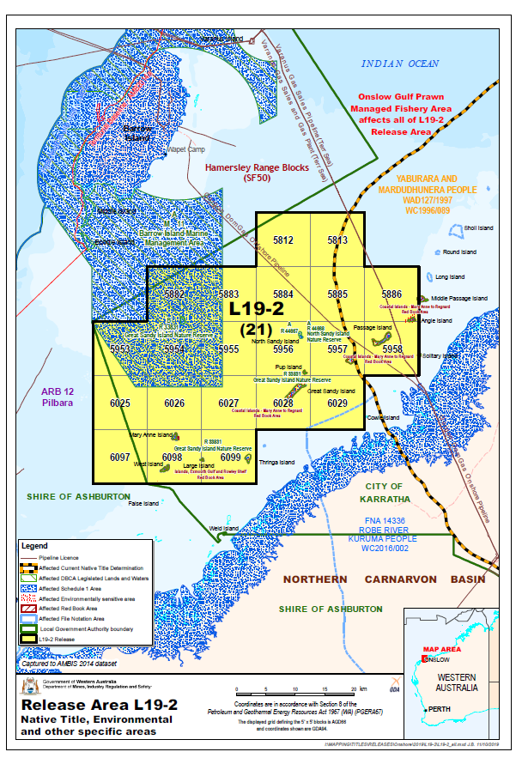

Special Notices
Applicants should be aware of the following special notice in relation to Area L19-2:
- It is intended that a condition under section 91B of the Petroleum and Geothermal Energy Resources Act 1967 will apply any petroleum exploration permit granted in respect of Areas L19-2 prohibiting the holder from entering upon:
  - any land, including islands, above the mean low water mark as is included in the permit area; and,
  - Crown reserves R33831 Great Sandy Island Nature Reserve, R44667, and R44668 North Sandy Island Nature Reserve.

Environmental considerations
Maritime area partially within Barrow Island Marine Management Area (north west blocks). The coastal waters of the Pilbara Region support a diverse array of marine life and are also recognised as biologically important areas for a number of protected species. Operational activities may require referral to the Environmental Protection Authority and consultation with the Department of Biodiversity, Conservation and Attractions, and for operational activities that have the potential to impact Commonwealth environmental interests, consultation with the Department of Environment and Energy (Cth) will be required. See map provided.

Available data and maps
- Area L19-2 Map
- Area L19-2 Area shapefile
- Area L19-2 Seismic lines and wells map
- 2D Seismic lines
- 3D Seismic polygons
- Aeromagnetic and Gravity surveys
- Area L19-2 Data listing
- Order forms for available data

Contact
For any general enquiries please contact the Resource Tenure team
Email: petroleum.titles@dmirs.wa.gov.au

For data enquiries please contact the Statutory and Resource Information team
Email: petdata@dmirs.wa.gov.au

